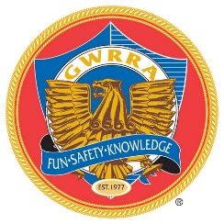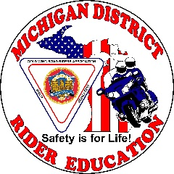
2022
MICHIGAN RIDER EDUCATION
RIDER COURSE REGISTRATION
GWRRA 1-UP/2-UP ARC (Advanced Rider Course)
GWRRA 1-UP/2-UP TRC (Trike Rider Course)
GWRRA 1-UP/2-UP SRC (Side Car Rider Course)
GWRRA 1-UP/2-UP AORC (Add On Rider Course)

Ionia Pontiac Grayling Sault Ste. Marie
May 7 June 4 July 9 August 13
ARC ARC ARC ARC
TRC TRC TRC TRC

All classes – ARC, TRC, AORC, ARC-R, TRC-R, and SRC– allow 1-up or 2-up training.
All participants must wear full riding gear: DOT helmet, eye protection, full finger gloves,
long sleeves, long pants and over-the-ankle boots or shoes.

ARC, TRC, AORC, and SRC Courses include Classroom and Range instruction.
All Riders must bring to class: valid operator license with motorcycle endorsement,
current vehicle registration, and current proof of insurance.

Confirmation Emails will be sent out about two (2) weeks before the requested course, and will indicate your Class Times and Locations. Classroom starts at 8:30 a.m.

COURSES WILL TAKE PLACE RAIN OR SHINE
GWRRA members - $35.00 Donation per bike per class
Make check payable to: GWRRA District-MI
7 days’ notice required for cancellations and refunds

Rider Drivers License #
Co-Rider
Address City State Zip
GWRRA Member # Chapter Phone #
Motorcycle Insurance Co. Policy #
Email Address _________________________________________________________

Please Note: Courses may change and/or be cancelled based on participation.
Mail completed registration form and $35.00 donation to:

Dennis Schulte 1498 Sand Beach Rd. Bad Axe, MI 48413
Make check payable to: GWRRA DISTRICT-MI
If you have questions, contact MI District Educator,
Dennis Schulte, at 989-415-7496, or michridered@gmail.com

